York House School
Mural Design Proposal Summary

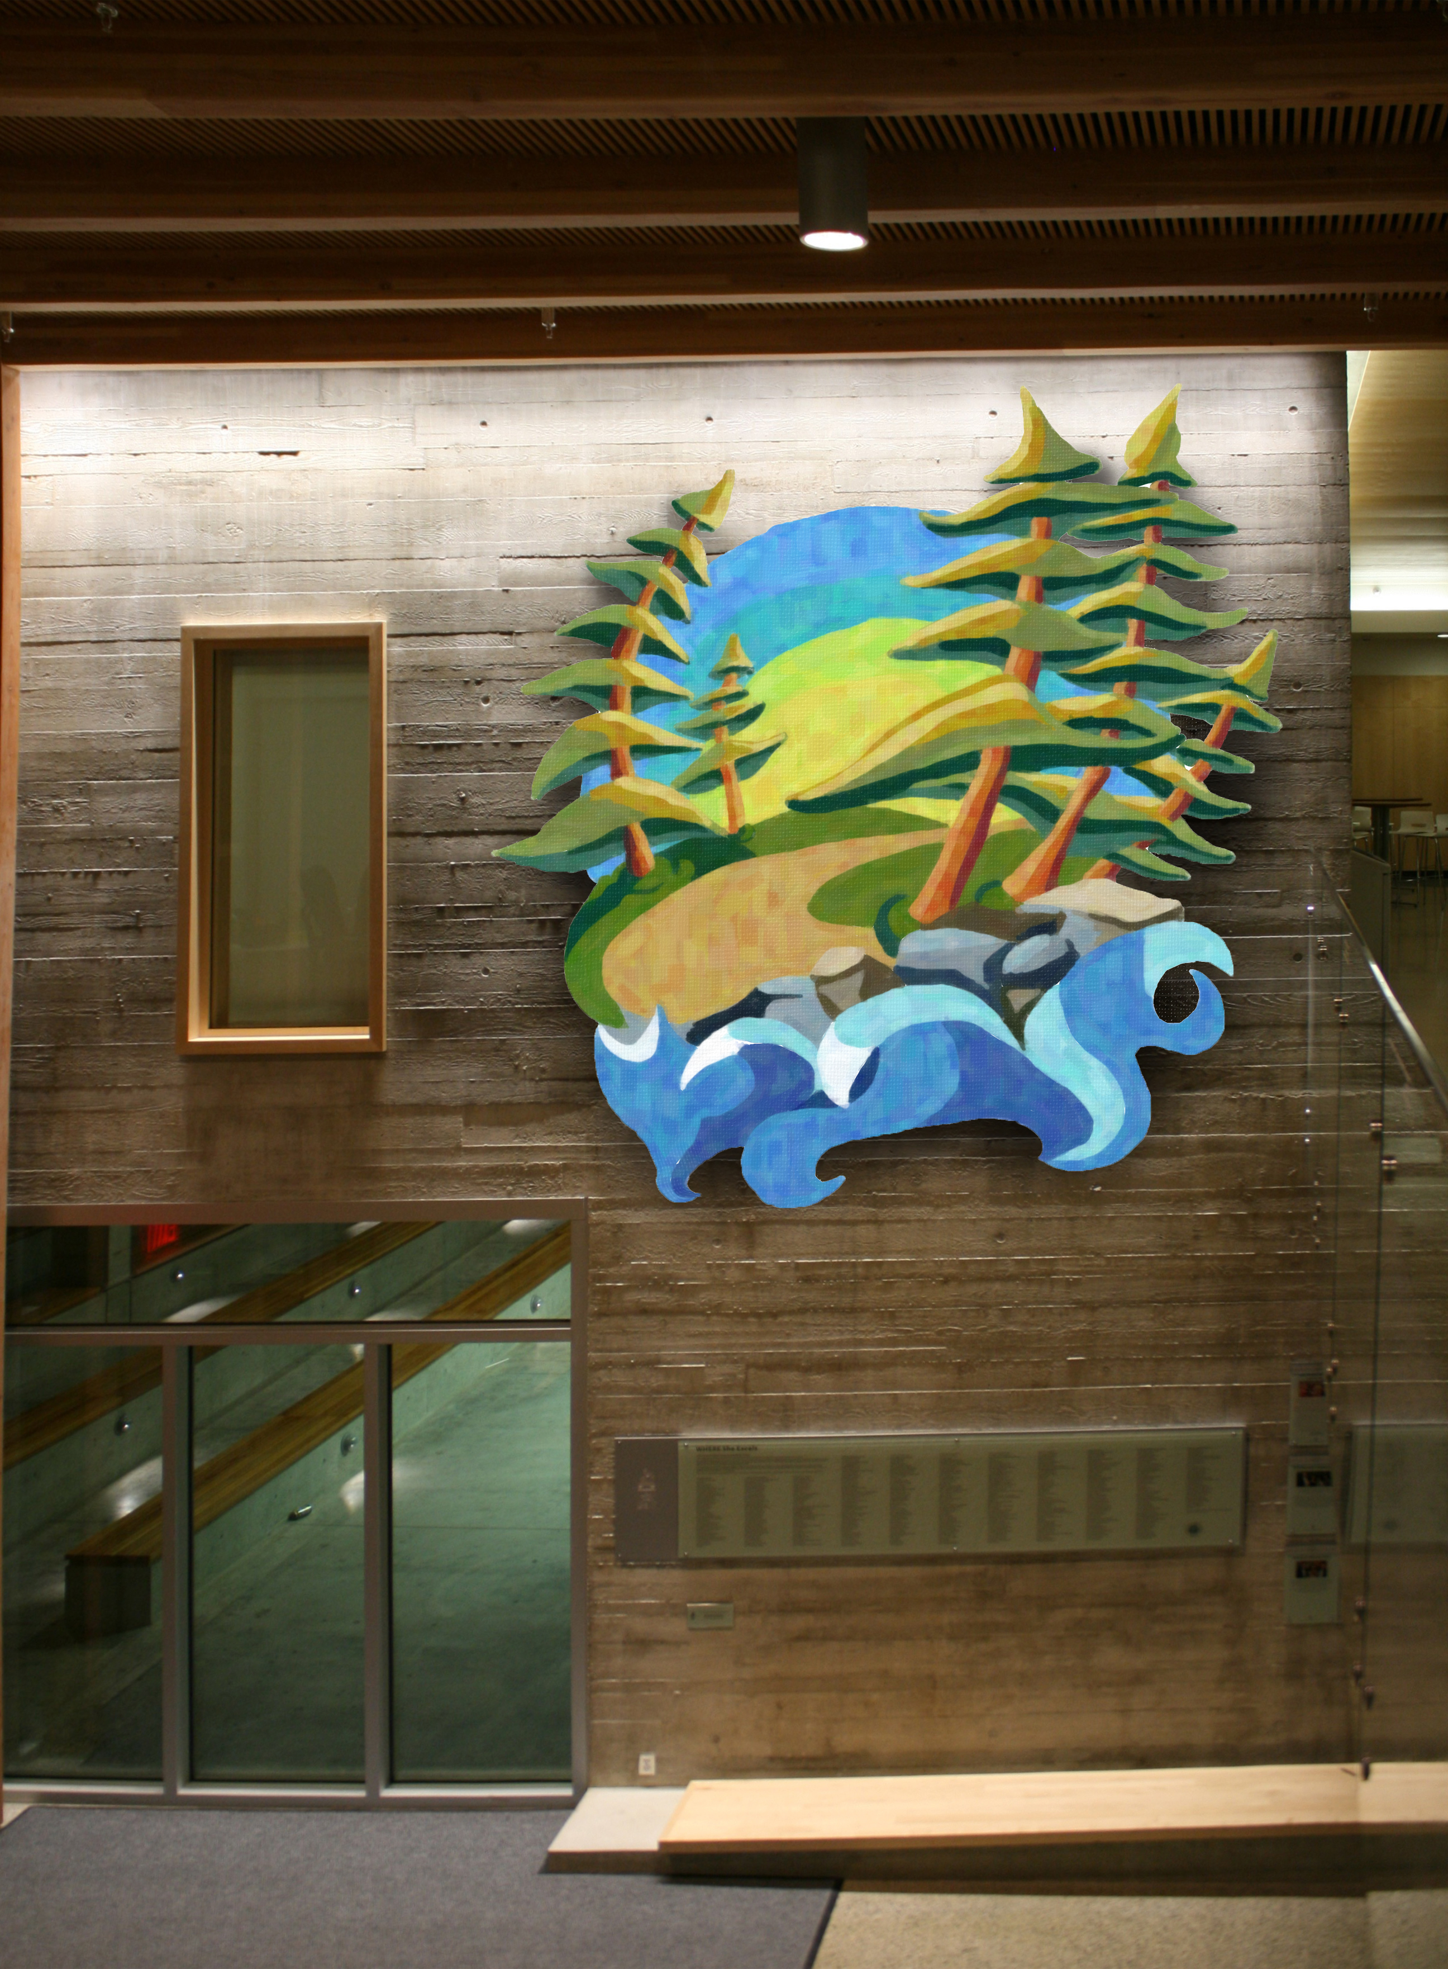
Introducing The Mural
- Overall design inspired by Emily Carr
- Design by Jessica Wall, class of 2017
- Theme: What makes me excited about life, about being a Yorkie and being a woman
- Location: Front foyer, near piano
- Size: Approximately 11’ X 11’
- Materials: wood, glue and acrylic paint
- Approximately 50 students participating, from grades 10 to 12
- Interlocking wood pieces allow for individual creative freedom; each piece will work as a painting individually

Benefits of the Mural
- Building community and group work
- Increase/reinforce pride in the school
- Visually beautiful, able to impact other students even if they did not participate
- Students who participate in the mural will exercise core competencies as per new BC curriculum; mural process based on UbD.
- All steps carefully planned to ensure success and memories to last a lifetime.
- Students are encouraged to think of what makes them special and precious as individuals, as well as think of how their own work fits in with everyone else’s. No piece of the puzzle is more important than the other. While each individual piece has meaning and value, the sum of all pieces is more valuable than each piece by itself. The same is true for people: together as a community, girls can achieve much more than when they are by themselves. This message is the core of the mural idea, and participating on this experience inevitably changes the participants towards a more community-oriented view of the world, rather than individual.

Resources needed
Below is the initial cost for the project considering the best quality acrylic paint we have available. Comparing with mural paint, the difference in cost is an extra $400; however, the result will be well worth it as the paint is much more vibrant.
I have reviewed funds available in the Senior Fine Art Department budget and we currently have around $7000 left for the year.
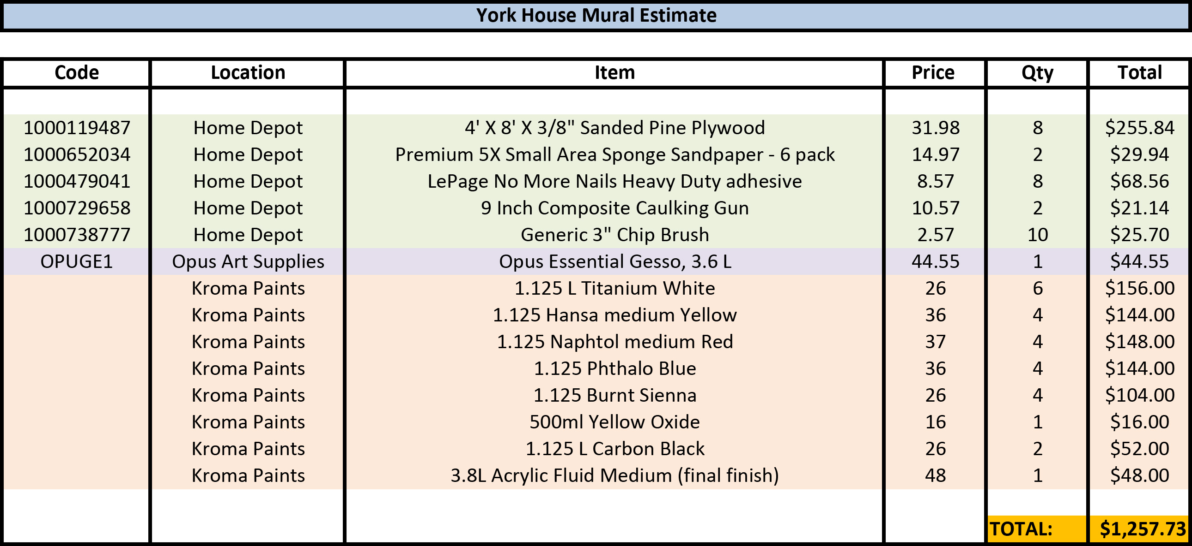

Please let me know if you have any questions, and have a great Holiday!

Best Regards,

Angela Jurgensen

